LAB (1) 18CSC303J (Database Management Systems)

RA1811029010016

Mohit Verma

TABLE department016

**Create table**

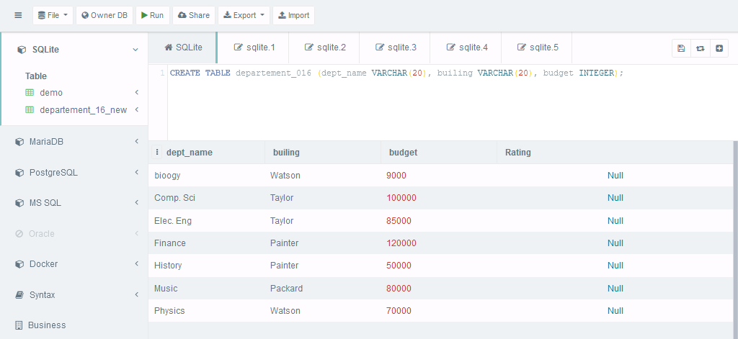

**Describe table**

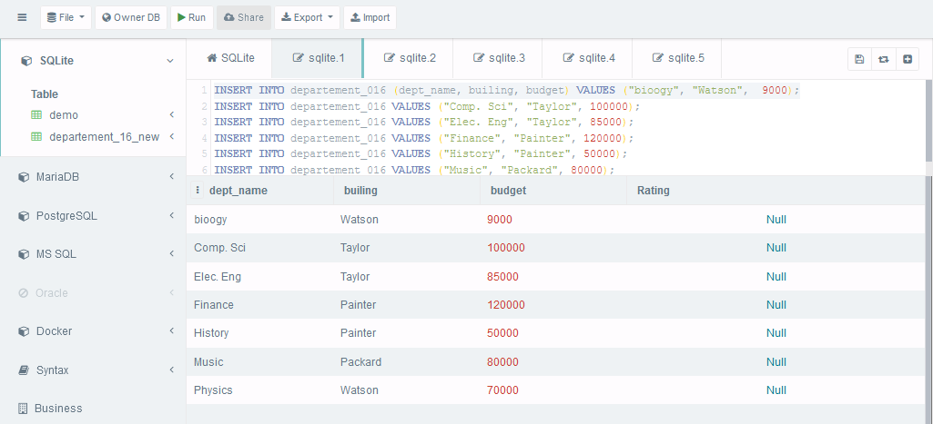

**Alter the field**

**Add new column RATING**

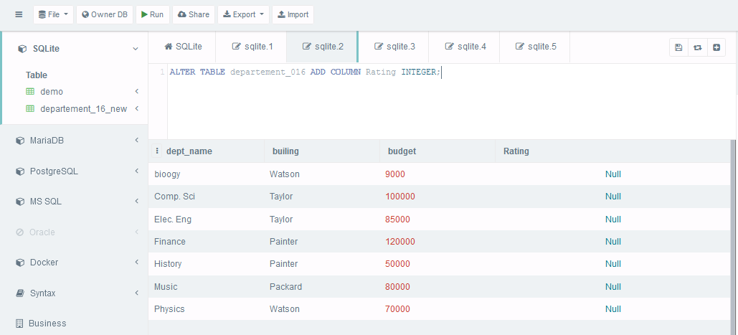

**Rename table**

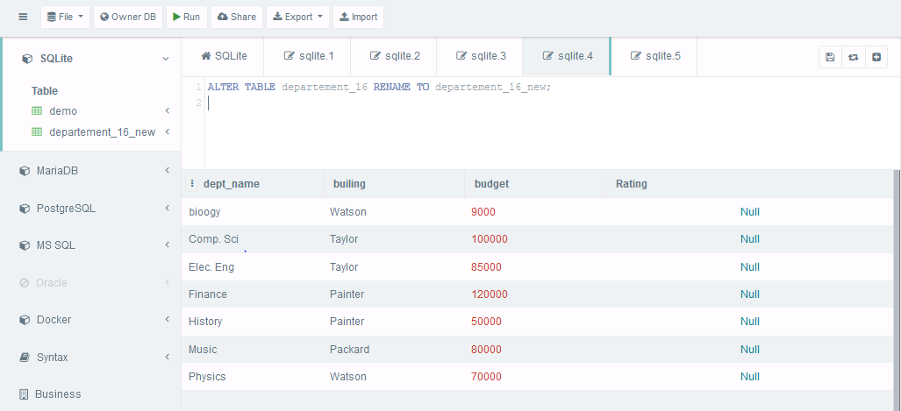

**Renamed Table**

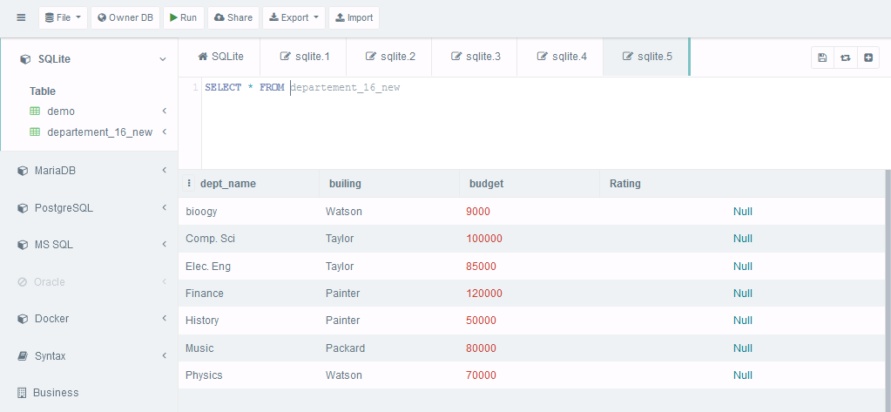

**TABLE section016**

**Create table**

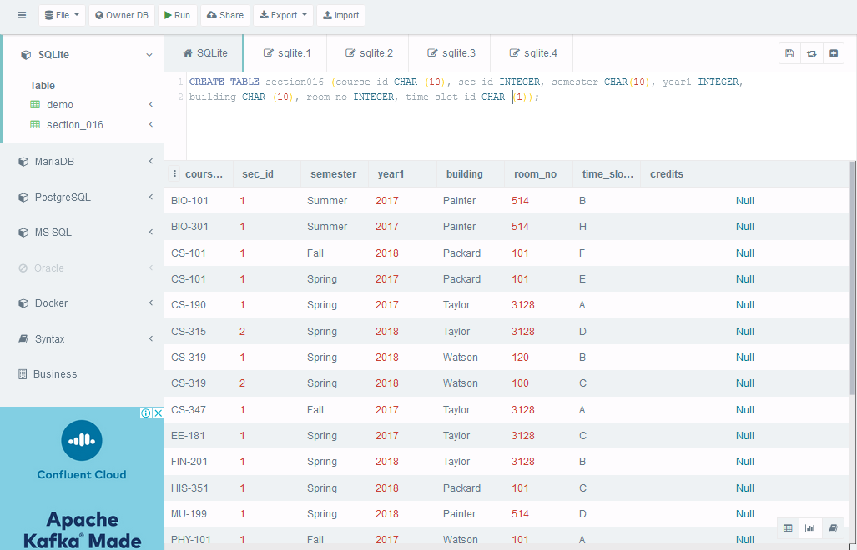

**Table description**

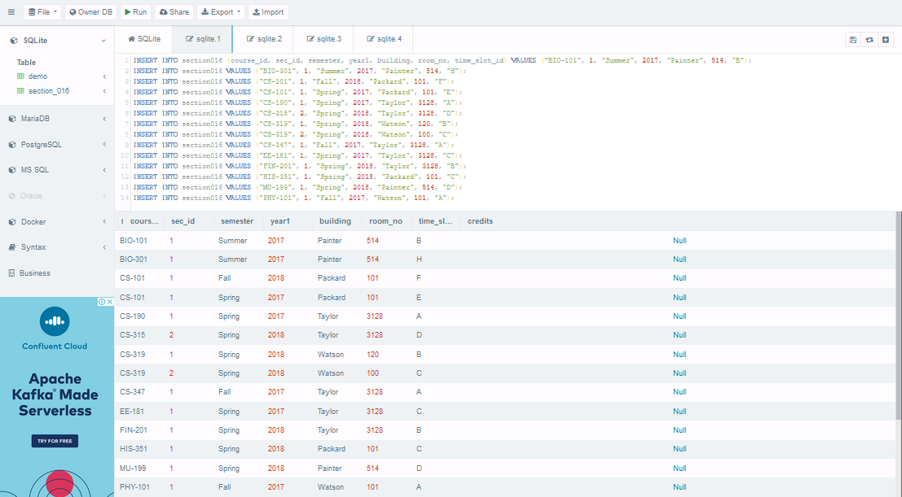

**Alter the field**

**Add new column CREDITS**

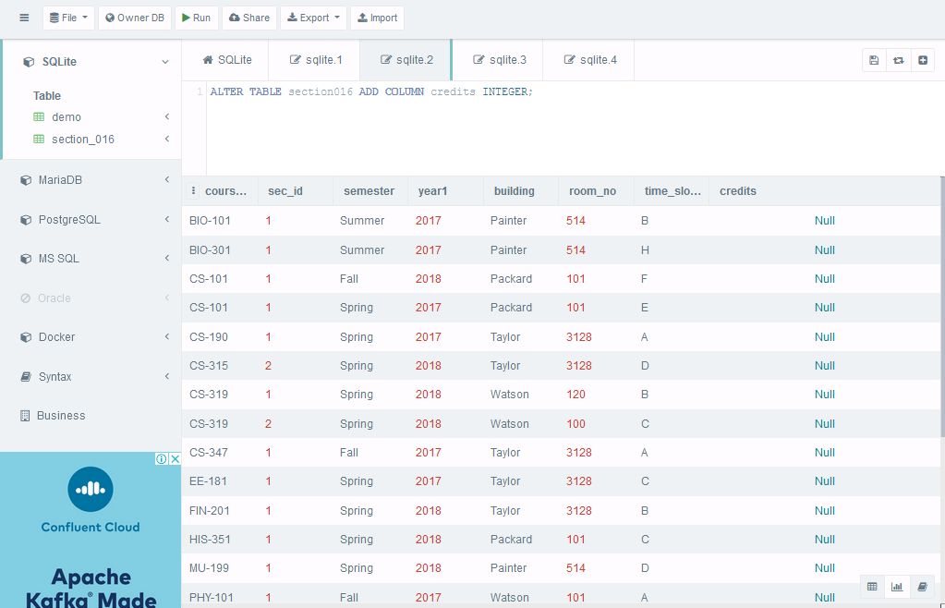

**Rename table**-

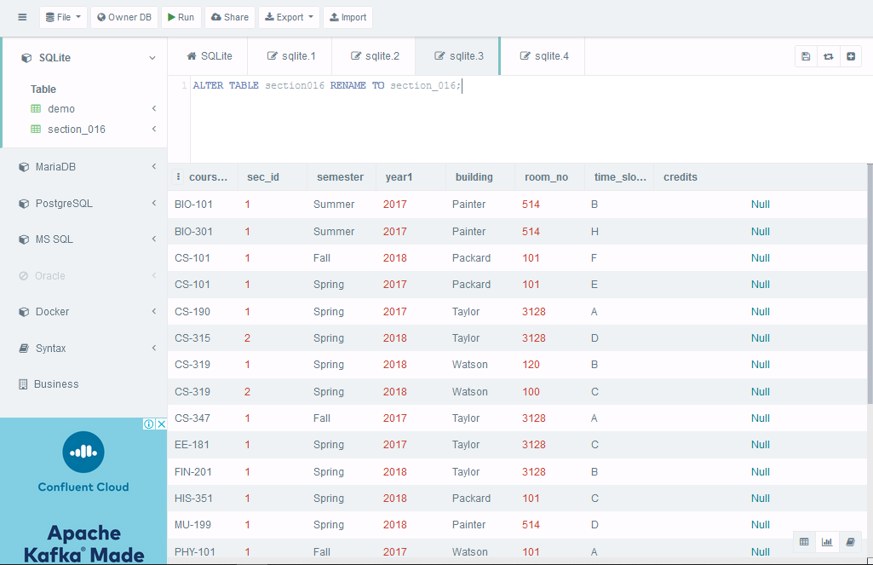

**New renamed table**

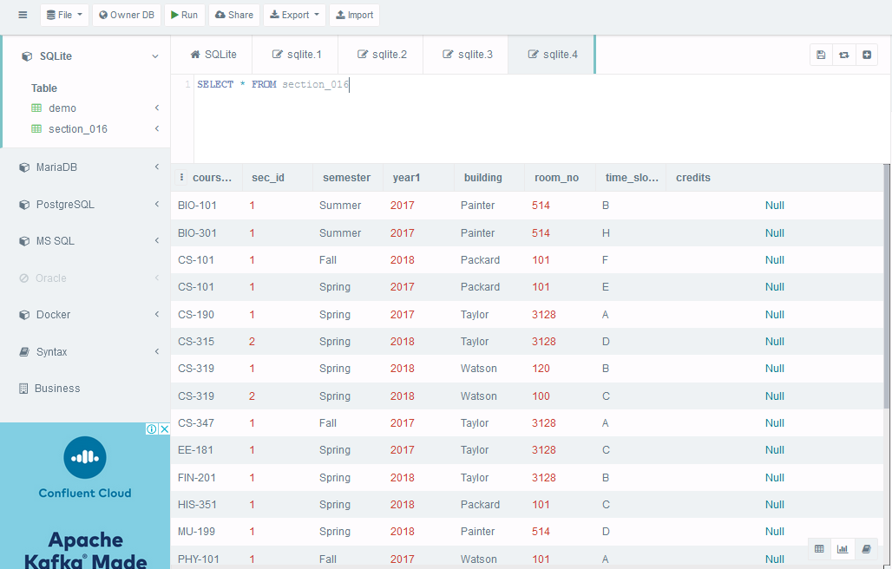

5. difference between truncate and drop

Objects deleted using DROP are permanently lost and it cannot be rolled back. Unlike TRUNCATE which only deletes the data of the tables, the DROP command deletes the data of the table as well as removes the entire schema/structure of the table from the database.

6. which set of actions is not possible in alter

* Column can’t be deleted with alter command.
* Column can’t be renamed a column.
* Column can’t be added in between of the existing columns.
* When a column is added, it will be added at the end of the table.